Experiment 8

Harsh Sandesara

Batch C, 49

UID: 2018130045

**Aim:**

Implementing socket programming in python

**Theory:**

Socket programming [1] is a way of connecting two nodes on a network to communicate with each other. One socket(node) listens on a particular port at an IP, while other socket reaches out to the other to form a connection. Server forms the listener socket while client reaches out to the server. They are the real backbones behind web browsing. In simpler terms there is a server and a client.

Sockets are the endpoints of a bidirectional communications channel. Sockets may communicate within a process, between processes on the same machine, or between processes on different continents.

A simple server-client program [1][2]:

*Server:*  
A server has a bind() method which binds it to a specific ip and port so that it can listen to incoming requests on that ip and port. A server has a listen() method which puts the server into listen mode. This allows the server to listen to incoming connections. And last a server has an accept() and close() method. The accept method initiates a connection with the client and the close method closes the connection with the client.

*Client:*

The socket.connect(hosname, port ) opens a TCP connection to hostname on the port.And socket.receive() receives the TCP message.

**Code:**

*server.py*

import socket

msg = 'Server side'

print(f'{len(msg):<10}'+msg)

s = socket.socket(socket.AF_INET, socket.SOCK_STREAM)

s.bind((socket.gethostname(), 8000))

s.listen(5)

while True:

client_socket, address = s.accept()

print(f'Connection established with {address}')

client_socket.send(bytes('Client Side', 'utf-8'))

*client.py*

import socket

s = socket.socket(socket.AF_INET, socket.SOCK_STREAM)

s.connect((socket.gethostname(), 8000))

msg = s.recv(1024)

print(msg.decode('utf-8'))

print("Disconnecting Client")

**Output:**

*server.py*

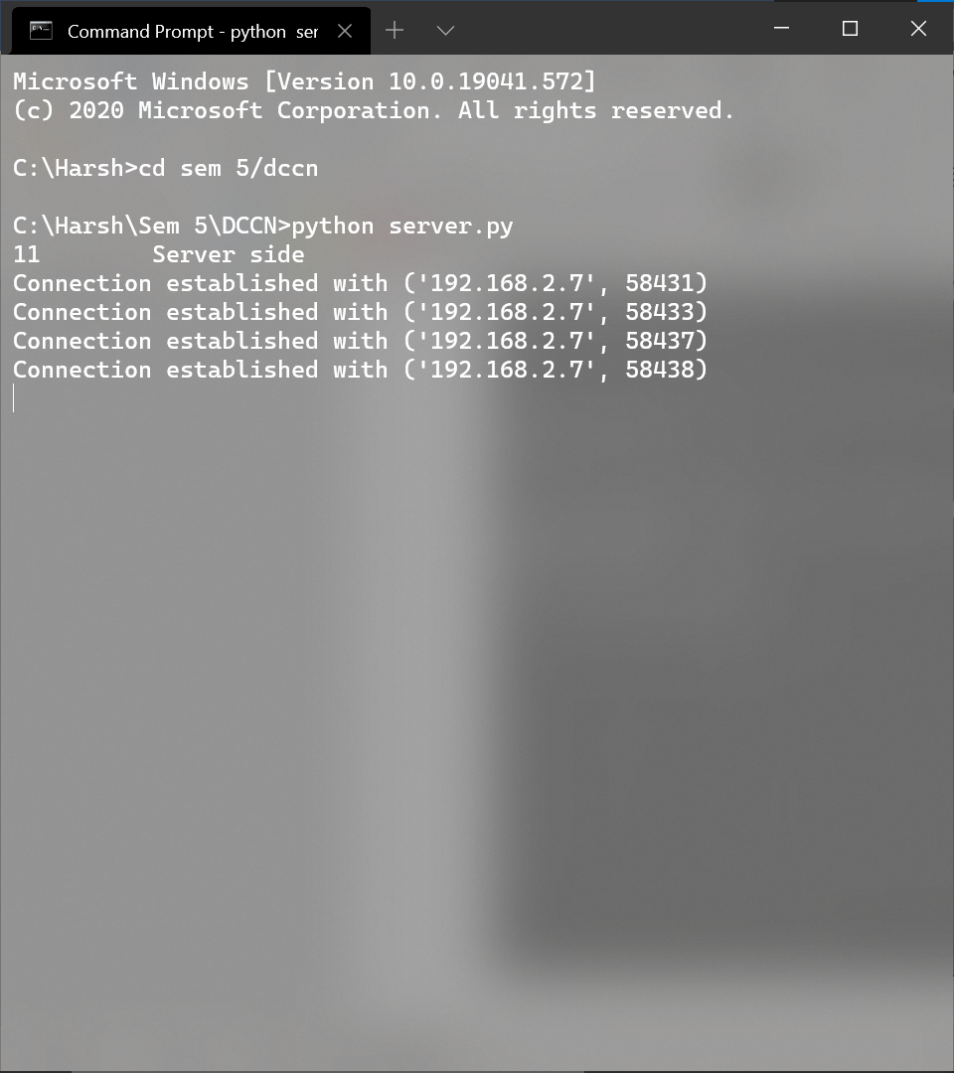

*client.py*



**Conclusion:**

* I have learnt the basics of socket programming and how to implement a basic client-server model in python.

**References:**

[1] https://www.geeksforgeeks.org/socket-programming-python/

[2] https://www.tutorialspoint.com/python/python_networking.htm